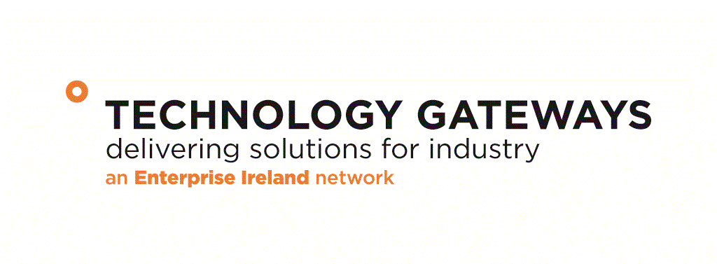

Technology Gateway Programme

Quarter | Tick
Q1 covering January to March
Q2 covering April to June
Q3 covering July to September
Q4 covering October to December

Gateway Name
Acronym:
EI Code
Institution:
College Contact:
Position:
Address:
E-mail:
Tel: |  | Mobile:
Gateway Manager:
Gateway Web Link

Current Project Timeframe as Approved
Start Date | 00/00/00 | Completion Date: | 00/00/00
Duration (Months)

Section 1: Personnel

EI Funded Gateway Staff
Position | Name
Gateway Manager
Research Engineer 1
Research Engineer 2
Research Engineer 3
Research Technician
Gateway Staff Funded from Other Sources
Name & Position | Funding Source
Total No of Gateway Staff | Male | Female
Change in Number Gateway Staff from Previous Quarter
Additional Summary Comments

Section 2 Industrial Steering Committee
(Please attach in Appendix 1 of this report the minutes of the last industrial steering committee meeting)

Role | Name & Affiliation
Chairperson
Industry Member 1
Industry Member 2
Industry Member 3
Industry Member 4
Industry Member 5
Industry Member 6
EI Representative
IoT Representative 1
IoT Representative 2

Section 3 Industrial Projects

Industrial Projects Completed 2016 | Targeted this Quarter | Achieved this Quarter | Targeted this year | Achieved this year
No of projects <€1.5k
No of projects > €1.5k
No of projects > €5k;
No of projects > €10k (innovation partnerships, direct funded etc)
Total € Value of Completed Projects
Total Industry Contribution
No of Licenses of IP / know how to industry
No. of Industry Referrals to other Gateways
No. of Collaborative Projects with Other Gateways / Research Groups
Additional Summary Information:

Ongoing Projects 2016 | Total No.
No of projects <€1.5k
No of projects > €1.5k
No of projects > €5k;
No of projects > €10k (innovation partnerships, direct funded etc)
Total € value of projects
Total Industry Contribution
Total Income This Quarter from Ongoing Projects
No of Licenses of IP / know how to transferred to industry
Additional Summary Information:

Section 4 Case Study (Company Approved Completed Industrial Project)
Company Name:
Funding Source & Value:
Project Title:
Profile of Company:

Problem to Be Solved:

How Gateway Delivered Solution for Industry:

Impact for the Company

Company Testimonial

Section 5 Development of Industrial Project Pipeline

Target Company | Target Project Area | Prospect for Conversion  % | Project Value  € | Contact Name | Date of Visits | Proposal Submitted Y/N? | Project  Secured

Section 6 Gateway Promotion Strategy:

Promotional Tool | Summary Description of Activity
Industry Days
Information Seminars
Training Events for Industry
Industry Network / Associations
Web Site Development
Media Exposure
Trade Shows Attended
Conferences Attended
Another

Section 7 Applied Research Activities

Applied Research Activity | Targeted this Quarter | Achieved this  Quarter
€ value of state research funding
i.e. EI Commercialisation Fund; SFI
€ value of other non-exchequer funding i.e. Horizon 20/20
€ value Other
Peer Reviewed Publications
Measures of IP generation (invention disclosure forms, patents filed, etc)
No of collaborative projects
Other
Additional Summary Information: i.e. Pipeline of New Proposals, Summary details of projects secured

Section 8 Risk Assessment

Briefly Outline Any Issues Risks Affecting the Performance of the Gateway

Section 9 Financial

 | Pay | Capital | Promotion | Travel  (Dom) | Travel  (OS) | Total
EI Grant
Cumulative Spend
Balance

Confidentiality:

All of the information provided will be confidential to Enterprise Ireland and any agents it appoints for evaluation purposes.
FOR OFFICE USE ONLY

Date Received:_________________ Referral To:_____________________ Date:____________
Cleared By: ___________________ Internal Evaluation: No □ Yes □
Approved By:

Appendix 1 Minutes of This Quarter Industrial Steering Committee Meeting

