|  |  |
| --- | --- |
| Date | Revision Notes |
| 18/11/2020 | Updated objectives section |
| 07/04/2021 | Updated with the Online Forms option and samples |
| 03/11/2023 | Updated Enterprise Ireland Logo |

# **Background and Objectives**

This document sets out the criteria for recording trainee time as a requirement for claim validation of Enterprise Ireland training projects, including LeanTransform and Operational Excellence programmes. Note that trainee time supported is limited to hours where the company has a loss of productive time (i.e. during working hours).

The fundamental requirement is that there is an audit trail for trainee records, that leads back to each trainee having made a declaration that they attended a particular training session/course/module. That audit trail could be in the form of a written signature OR in the form of an auditable electronic ‘footprint’ that is linked to the trainee login to an enterprise system[1].

For external trainer time we expect to see an invoice (with backup documentation if appropriate) showing;

* The training courses provided (training title, dates, duration)
* Any training advisory services time charged (with a breakdown of activities)[2]
* Cost per day and number of days

# **Scenario 1 - Training Records captured for each training session**

## **In-person Training (Paper records)**

Where a training module is held in a classroom/learning assignment setting with everyone physically present, capturing a training record may be easiest to do on a paper form and to ask each participant to sign a record to state that they attended the training session. A Training record sheet should contain;

* Title of Programme/course/module
* Date of training
* Duration
* Signature of each participant
* Signature of the Trainer

An example training record is given below and at the end of this document.

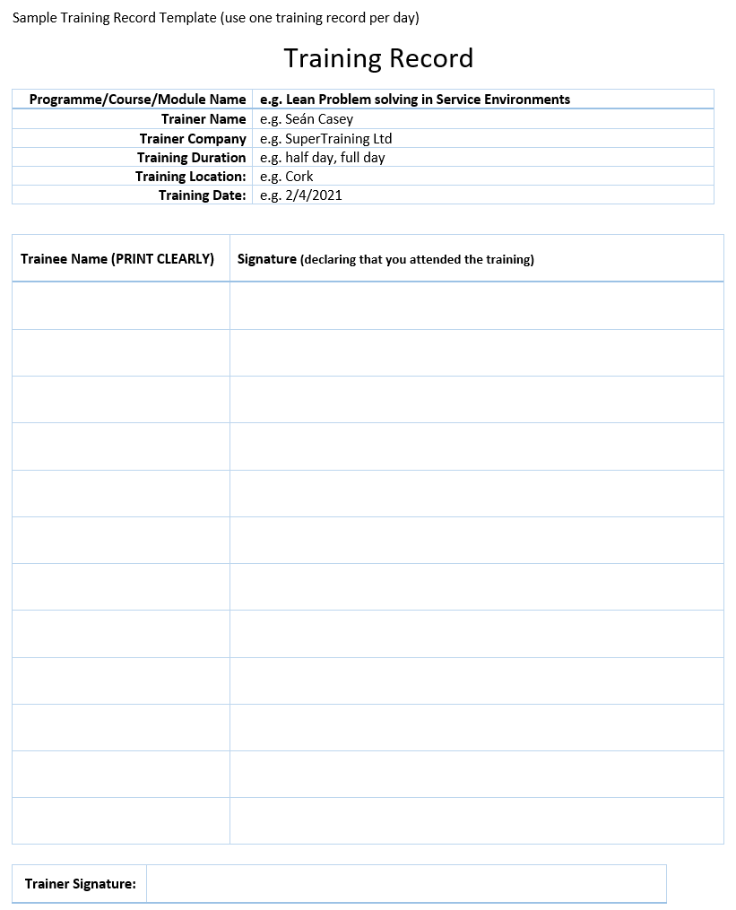

## **Online Training (Cloud based form to gather training records)**

In the case that the training is being held online (Zoom, Teams, Webex, Hangouts, etc), then gathering physical signatures is not possible. Where a company has access to cloud based office software such as Google Apps or Microsoft Office365, training records could be captured using the online Forms features of those platforms.

The key criteria are that the online forms system shows an audit trail of each trainee being logged in to the company’s cloud system (e.g. Google Apps or Office365) so that their username/email address is captured. This means that an anonymous public facing survey tool is NOT adequate[3].

In this scenario, the company would create a training record ‘form’ and send to each participant covering each training course/module. This could look like the following (note the mobile view option);

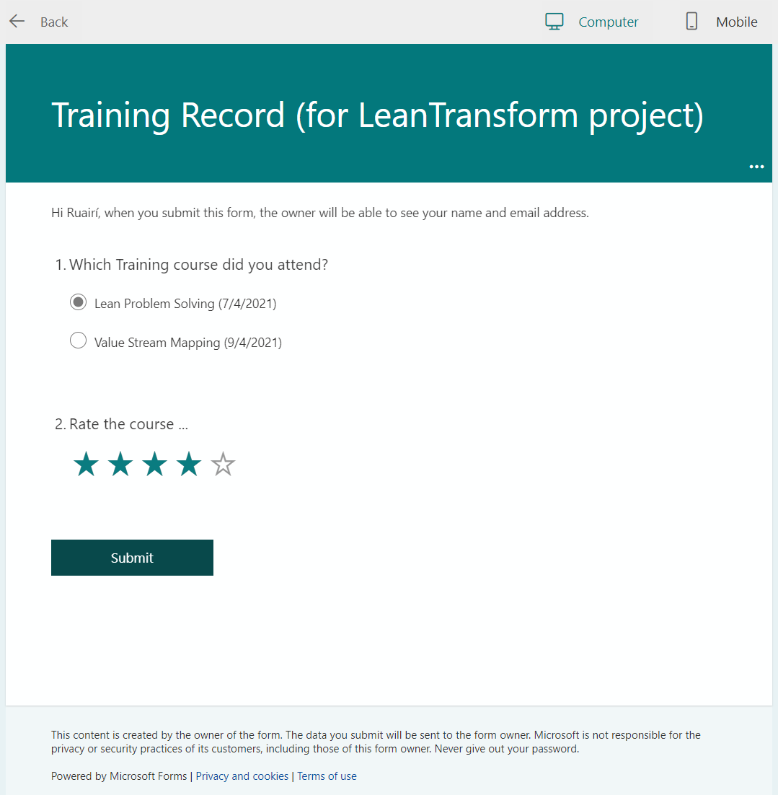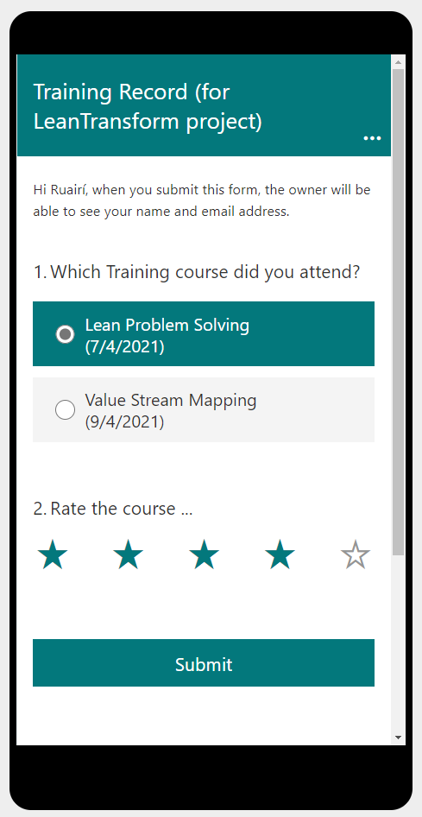

The advantage of this approach is that the system will create a record that can be easily exported for the claim and the original form capture system can be shown to EI staff as evidence of an audit trail.

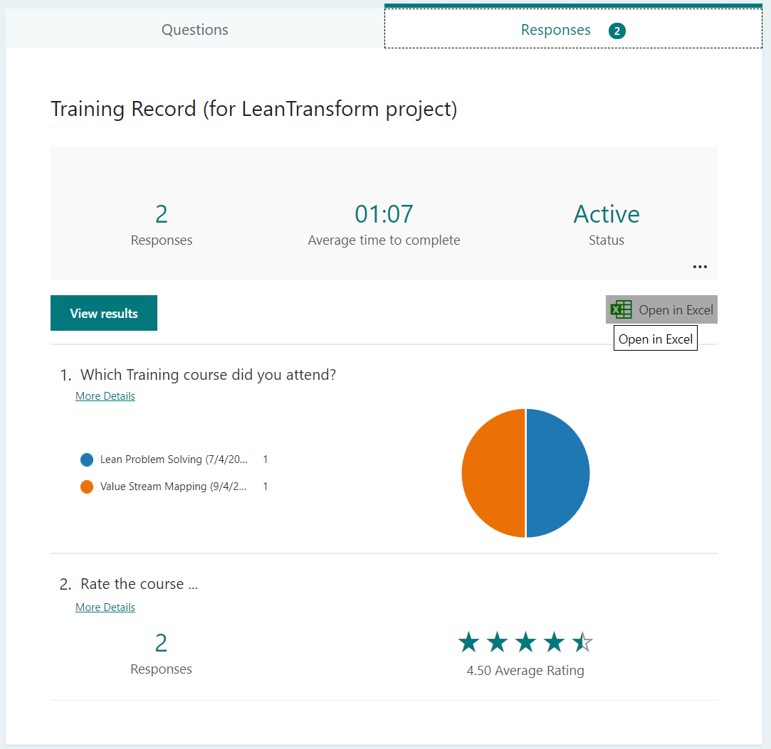

The form could also be used to gather feedback on the course which could prove useful to the company.

Note that screen-shots of people in a Teams/Zoom/WebEx/Google meeting room are not accepted as they lack the concept of each particpant making an independent declaration of attendance.

## **Online Training (Electronic Signatures applied to a training record)**

An alternative to the Online Forms method above, would be to use an electronic signature software platform such as DocuSign, Adobe Acrobat, DocHub, etc. In that case, a record sheet could be generated in the same way as a paper training record and electronic signatures attached.

Note that these are paid software services, although a paid account is only required for the person(s) sending the training record template around for signing.

Example; 

Note that scans or pictures of signatures applied to a document are not acceptable as signatures as they are too easily replicated without the knowledge of the signer.

# **Scenario 2 – Training log per person**

In some cases, the training is easier to capture per person rather than per course. This may be the case for instance where one individual is doing a training programme over a number of sessions. The concept of a training log may be appropriate in this case. This would allow for a single signature at the end of a training programme from the trainee with the course details and dates clearly laid out as shown in the example below

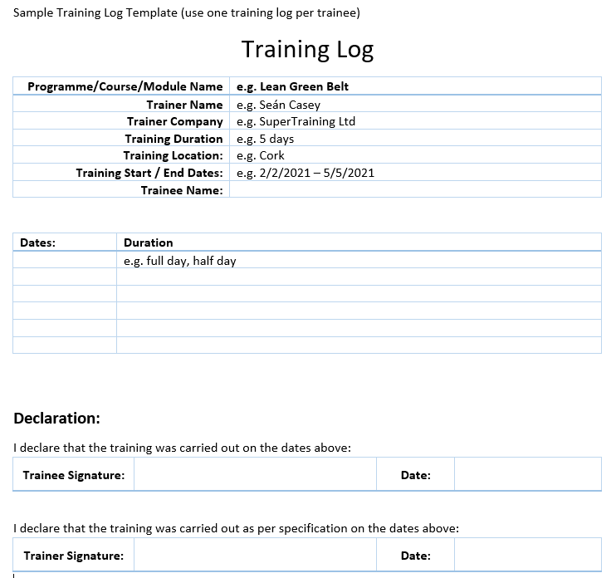

An example training log is given at the end of this document in a format that can be reused.

# **Scenario 3 - Training Records captured in central electronic systems**

## **Online Project / Timesheet systems**

Where a company uses a centralised time recording software package to capture time that staff spend on projects (such as Asana, Jira, Harvest, etc), that system may be used to capture time spent on training programmes instead of using a separate training records process. The system needs an individual login for the person who is recording their time, a way of ensuring that the input is done around the time of the activity, a way of assigning a person’s time against the funded training as opposed to other activities in the company and the time approved by a line manager.

The system should have the following features;

* It is password protected for the staff member and the line manager
* It records time on a daily basis
* It provides a series of activity and project codes to identify work content (clear separation of activities)
* It provides a date and time stamp for when the staff member entered the time records
* It provides a date and time stamp for when the manager approved the time records
* It is not possible for the staff member’s manager to modify the time record for the staff member
* Reports generated from the system showing summaries of time spent on a particular training programme

EI will likely request a demonstration of the system – how is time recorded, etc.

## **Learning Management Systems**

In the scenario where a company uses a centralised Learning Management System (LMS) to track training, then this may be used to provide evidence of training having been carried out, provided the following criteria are met;

* There is a separate Login for each trainee.
* Training records cannot be modified by trainees or by managers (i.e. they are password protected with an audit trail)
* There is a report generated directly from the LMS with;
  + Date of training recorded
  + Programme/course/module title clearly marked in the report
  + Trainee names listed
  + Completion status visible for each trainee
* We will require information on the training specification (including duration, and learning objectives). Note that some systems do not record the actual time spent, in which case we may accept the estimated time for the programme as per the training specification.

EI will likely request a demonstration of the system – how is time recorded, etc.

## **Online Learning Platform reports**

In the scenario where training has been approved for training to be delivered via an online learning platform (such as LinkedIn Online Learning), then claiming for trainee time can be difficult as trainee time can only be grant aided for time spent during work hours and for approved courses only.

Where staff are expected to train outside of work hours as part of their own continuous professional development, then there is effectively no cost to the company and therefore no grant payable.

However, if the company is approved for such training and can prove that training carried out was for approved programmes, during paid work hours such that there were reduced hours available for production work, then trainee time may be supported.

# **Scenario 4 - Training records for External courses**

This is where a company has been approved for training costs related to externally provided courses for which an invoice and proof of payment are available.

## **External ‘Short’ courses**

Where course durations are in the order of days – e.g. 5 day Lean Green Belt programme

Evidence of staff attendance / trainee time could be provided in the form of;

* Timesheet or or electronic recording of time spent (as per previous sections), or
* A copy of a dated course completion certificate along with evidence of the training specification clearly showing the course duration.

## **External ‘Long’ courses**

Where course durations are in the order of months – e.g. Lean Black Belt Masters programme. These are typically academic programmes carried out in 3rd level Institutions.

While course fees may be approved for such courses as part of a training grant, Enterprise Ireland policy is not to support staff time for academic programmes as training time spent is typically outside of work hours, so does not constitute a cost for the company in terms of a loss of work hours available (no exception made for paid study leave which is at the discretion of the company).

Sample Training Record Template (use one training record per day)

Training Record

|  |  |
| --- | --- |
| Programme/Course/Module Name | e.g. Lean Problem solving in Service Environments |
| Trainer Name | e.g. Seán Casey |
| Trainer Company | e.g. SuperTraining Ltd |
| Training Duration | e.g. half day, full day |
| Training Location: | e.g. Cork |
| Training Date: | e.g. 2/4/2021 |

|  |  |
| --- | --- |
| Trainee Name (PRINT CLEARLY) | Signature (declaring that you attended the training) |
|  |  |
|  |  |
|  |  |
|  |  |
|  |  |
|  |  |
|  |  |
|  |  |
|  |  |
|  |  |
|  |  |
|  |  |

|  |  |
| --- | --- |
| Trainer Signature: |  |

Sample Training Log Template (use one training log per trainee)

Training Log

|  |  |
| --- | --- |
| Programme/Course/Module Name | e.g. Lean Green Belt |
| Trainer Name | e.g. Seán Casey |
| Trainer Company | e.g. SuperTraining Ltd |
| Training Duration | e.g. 5 days |
| Training Location: | e.g. Cork |
| Training Start / End Dates: | e.g. 2/2/2021 – 5/5/2021 |
| Trainee Name: |  |

|  |  |
| --- | --- |
| Dates: | Duration |
|  | e.g. full day, half day |
|  |  |
|  |  |
|  |  |
|  |  |
|  |  |

**Declaration:**

I declare that the training was carried out on the dates above:

|  |  |  |  |
| --- | --- | --- | --- |
| Trainee Signature: |  | Date: |  |

I declare that the training was carried out as per specification on the dates above:

|  |  |  |  |
| --- | --- | --- | --- |
| Trainer Signature: |  | Date: |  |

1. This could be a Learning Management System or using secure cloud based data capture systems such as Google Forms or Microsoft Forms. The company must be able to show an audit trail linking back to an employee login.
2. This should not just be a single line saying ‘Consultancy’ for example
3. We have seen where survey monkey can be used to send out explicit email invitations (as opposed to a web link), thus tying the response to their email address which may be acceptable.